CONFIDENTIAL CS/OCT 2026/MAT133

UNIVERSITI TEKNOLOGI MARA FINAL EXAMINATION

COURSE
COURSE CODE
EXAMINATION TIME
PRE CALCULUS
MAT133 OCTOBER 2026
2 HOURS

INSTRUCTIONS TO CANDIDATES

- This question paper consists of 5 questions.

- Answer ALL questions in the Answer Booklet. Start each answer on a new page.

- Do not bring any material into the examination room unless permission is given by the invigilator .
- Please check to make sure that this examination pack consists of: i) the Question Paper
  - a one - page Append ix 1
  - an Answer Booklet - provided by the Faculty
  - a graph paper - provided by the Faculty

- Answer ALL questions in English.

/

DO NOT TURN THIS PAGE UNTIL YOU ARE TOLD TO DO SO

This examination paper consists of 6 printed pages

QUESTION 1
a) Solve the inequality 3x² + 24x + 45 > 0.
(5 marks)
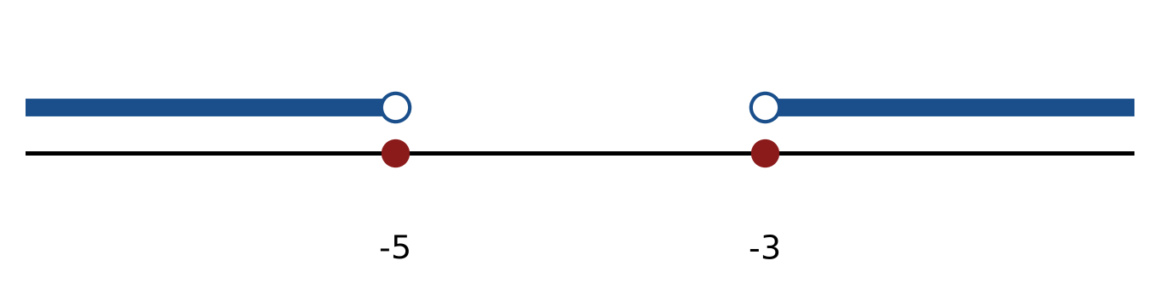
Figure: critical values.
b) Solve the inequality |x + 1| <= 7. Express the answer in interval notation and on a number line.
(5 marks)
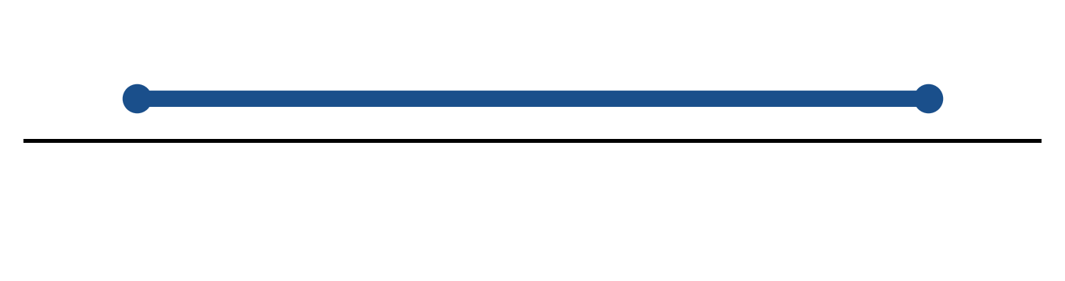
Figure: solution on a number line.
c) Solve the equation |-5x - 2| = 3.
(4 marks)
QUESTION 2
a) Apply graph-transformation techniques to sketch y = -3(x - 1)² + 5. State the vertex and the y-intercept.
(5 marks)
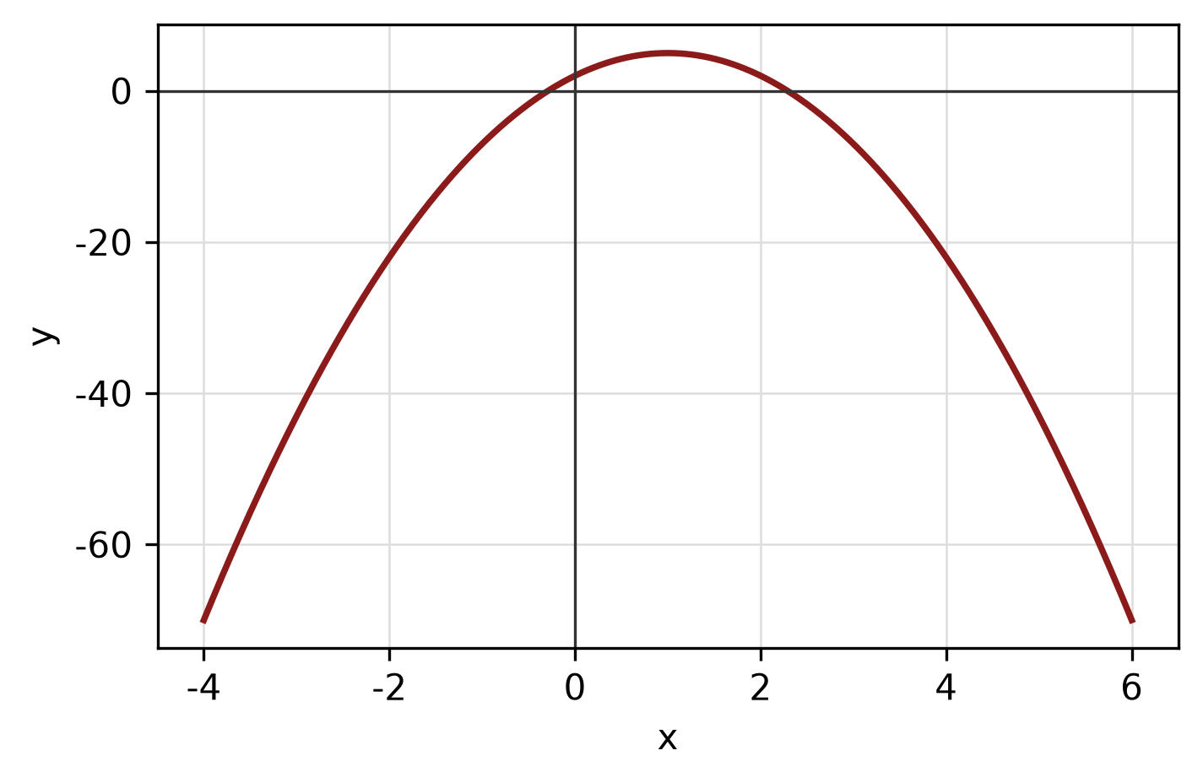
Figure: transformed graph.
b) Determine algebraically whether f(x) = x^4 + x² - 5 is even, odd or neither. State the symmetry of its graph.
(4 marks)
c) Find the standard equation of the parabola with focus (-1, -1) and directrix y = -5. State its vertex.
(5 marks)
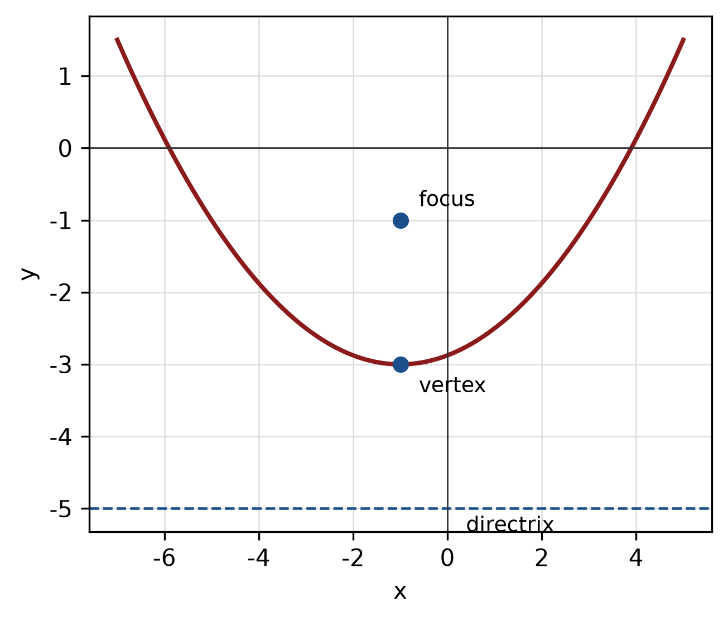
Figure: parabola with focus and directrix.
QUESTION 3
a) Given z₁ = -2 - 4i and z₂ = -5 + 6i, find z₁ × z₂ in the form a + bi.
(4 marks)
b) Evaluate i^37 and simplify completely.
(3 marks)
c) Show that x + 3 is a factor of f(x) = -x^3 - 4x² - 6x - 9 by using the factor theorem. Hence factorise f(x) completely.
(5 marks)
QUESTION 4
a) Solve the simultaneous equations
x + 4y = -13
-x + y = -2.
(4 marks)
b) Write a system of inequalities that describes the shaded triangular region with vertices (0, 0), (3, 0) and (0, 3).
(5 marks)
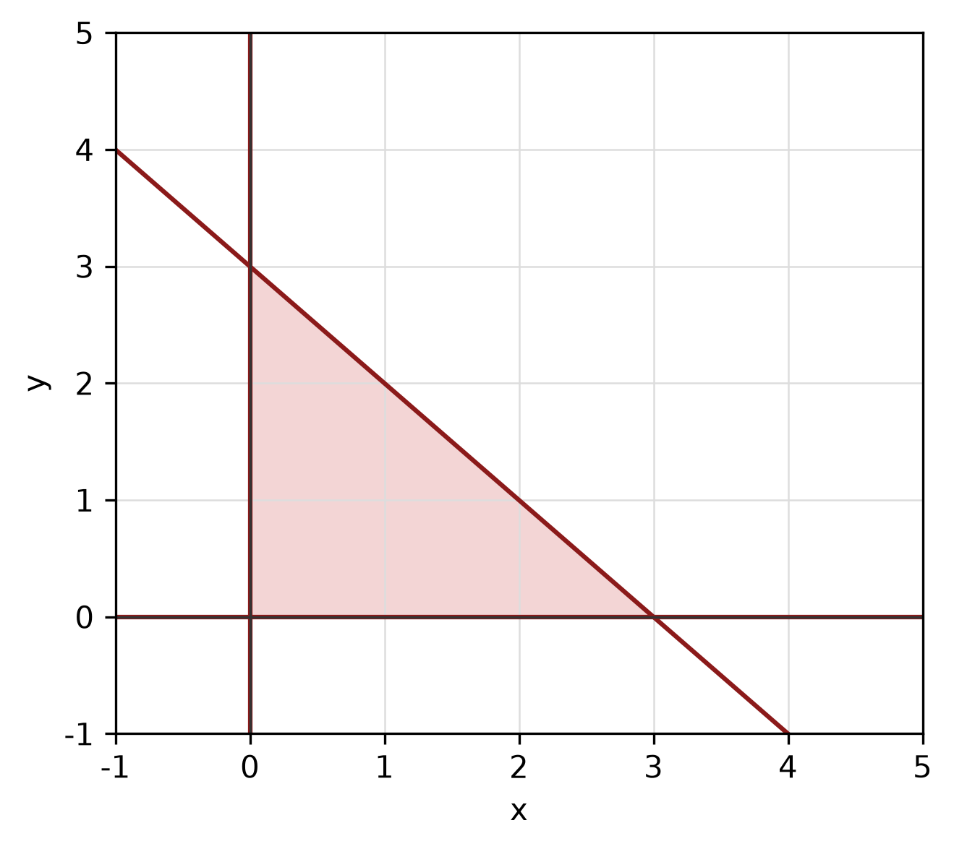
Figure: shaded triangular region.
c) Write x² - 6x + y² - 10y + 30 = 0 in standard form. Hence state the centre and radius and sketch the circle.
(5 marks)
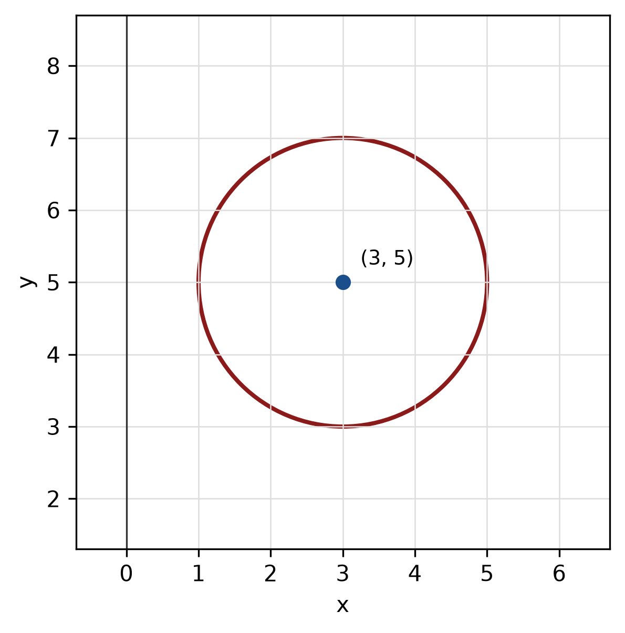
Figure: circle.
QUESTION 5
a) For y = -2 sin(3x + 60) + 1, state the amplitude, period and phase shift, then sketch the graph for -180° ≤ x ≤ 180°.
(5 marks)
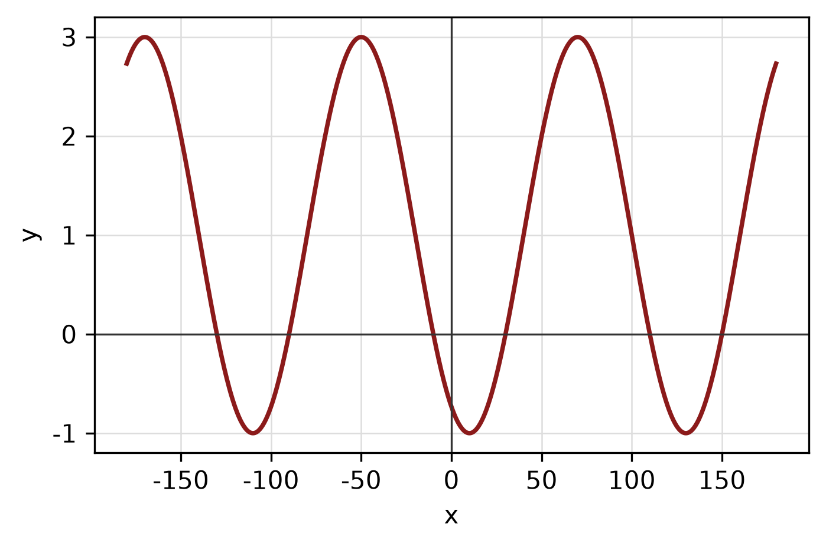
Figure: trigonometric graph.
b) Convert 135° to radians, and convert 2π/3 radians to degrees.
(3 marks)
c) Find the area of triangle ABC with a = 11 cm, b = 10 cm and included angle C = 45°.
(4 marks)
END OF QUESTION PAPER

APPENDIX 1
Formula sheet (as supplied with the paper).
sin² A + cos² A = 1 | tan² A + 1 = sec² A
sin(A + B) = sin A cos B + cos A sin B | tan 2A = 2 tan A / (1 − tan² A)
cos(A + B) = cos A cos B − sin A sin B | Arc length, s = rθ
tan(A − B) = (tan A − tan B) / (1 + tan A tan B) | Area of sector = ½r²θ
cos 2A = cos² A − sin² A | a / sin A = b / sin B = c / sin C
cos 2A = 1 − 2sin² A = 2cos² A − 1 | a² = b² + c² − 2bc cos A
sin 2A = 2 sin A cos A | Area of triangle = ½ab sin C

